**Team D - Bedudoori, Sanjay**

Bedudoori, Sanjay

Team number: D - Team name - Phoenix

Client name: Dr. Michael Oudshoorn

Project: Slack/HipChat collaboration tool

Your team role: Primary Contact

Roles and Responsibilities: I am primary contact to the client and represents the team. I am responsible for conducting standup meetings, communicate project progress, issues and changes to client.

**Project Requirements:**

* Writing problem statement – 75% complete. Will discuss with the client and update problem statement accordingly. Progress of this requirement is on track. Criticality - Required for GDP1 completion.
* Gathering client requirements and categorizing them to must have and nice to have things – 50% complete. Progress of this requirement is on track. Criticality – Required for GDP1 completion.

**Accomplishments made last week:**

* Analyzed how the overall system works with system overview diagrams.
* Use case diagrams for Task management requirement.

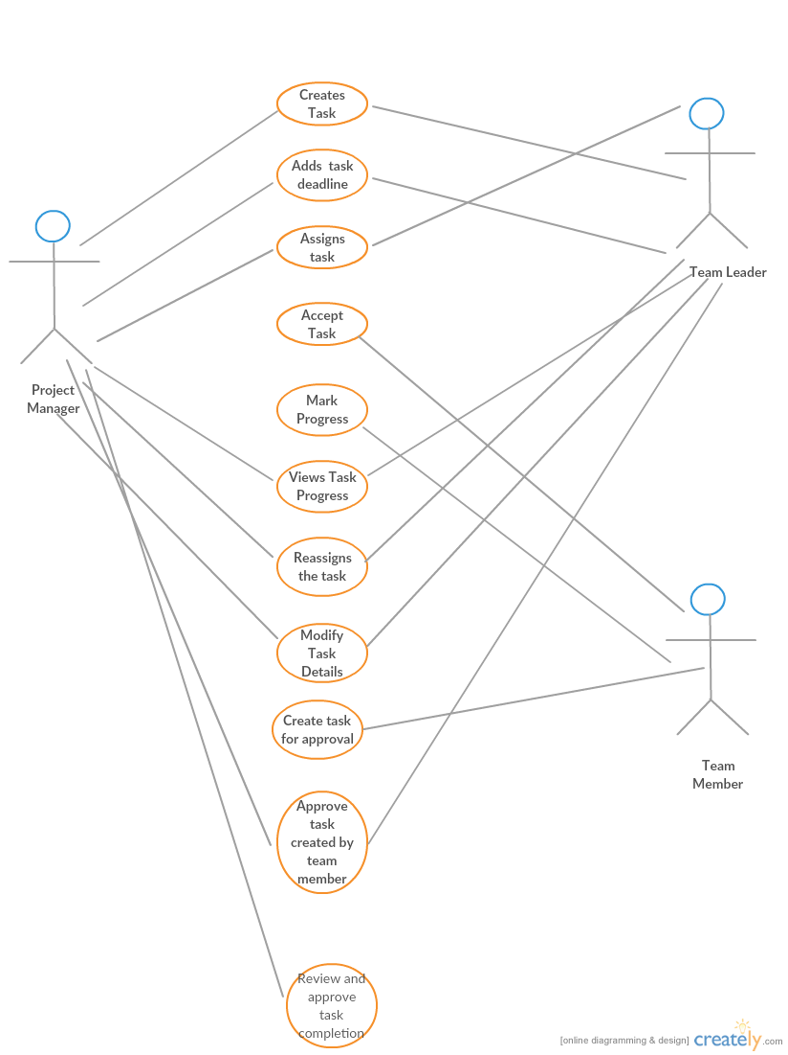

* Documented part of test plan document.
* I have started documenting requirement document on task management and there are changes yet to be made.

**What are plans to accomplish next week:**

By end of this week, I plan to deliver system overview diagram and contribute to requirement document the test cases, use cases related to task management. Write requirement document for user signup/login along with use cases and test cases. Update test plan document with respect to requirement document. Research on adding project management tools like Gantt chart and pert chart into our project. Expected effort this week (5 days * 7.8 hours = 39 hours).

**Copy of complete post from one week ago:**

**Team D - Bedudoori, Sanjay**

Bedudoori, Sanjay

Team number: D - Team name - Pheonix

Client name: Dr. Michael Oudshoorn

Project: Slack/Hipchat collaboration tool

Your team role: Primary Contact

Roles and Responsibilities: I am primary contact to the client and represents the team. I am responsible for conducting standup meetings, communicate project progress, issues and changes to client.

**Project Requirements:**

* Writing problem statement – 25% complete. Will discuss with the client and update problem statement accordingly. Progress of this requirement is on track. Criticality - Required for GDP completion.
* Gathering client requirements and categorizing them to must have and nice to have things – 12% complete. Progress of this requirement is on track. Criticality – Required for GDP – 1 completion.
* Choosing platform, whether we are implementing the project as a desktop application or web application. 0 % complete. It is critical – core functionality for the client.
* What tools and technologies are we going to use in the project?
  + If it is a web project – Is it feasible to use MEAN stack?
  + If it is a desktop application – Choose between Java, ASP.net or others.

0% complete. It is critical – core functionality for the client.

**Accomplishments made last week:**

* Meeting client and knowing more about project requirements.
* Shared contact details with team members.
* GitHub link to the project is created and learned how to push, pull and commit to repository.
* Planned things that must be accomplished by next week.
* Learned about how slack, hip chat and other collaboration tool works.

**What are plans to accomplish next week:**

* Exploring advantages of desktop application and web application, and making decision of which one to choose. (3 days – 3 hours/day – 3*3 = 9 hours)
* Researching on languages and tools that will be used to build the project. (2 days – 3 hours/day – 2*3 = 6 hours)

**What is the riskiest component under development?**

Whether to do platform dependent or independent software or a web application.

**What active efforts are most critical for client acceptance or GDP completion?**

Regular client meetings, understanding the requirements and timely submission of deliverables.